Big Data Forklift Operations Analysis using Spark and MongoDB
Project Report
Duxing Li (2304632)

Table of Contents
1 First Level Heading (Heading 1) 1
1.1 Second Level Heading (Heading 2) 1
1.2 Second Level Heading (Heading 2) 1
1.2.1 Third Level Heading (Heading 3) 1
1.2.2 Third Level Heading (Heading 3) 2
2 First Level Heading (Heading 1) 2
References 4

The table of contents is automatically generated once you apply the Heading paragraph styles and update TOC. Also figures, tables, and equations tables below are automatically generated once you use captions. Delete this sample text.
The tables of figures, tables, and equations will be generated automatically once you use the respective styles in your document. Delete these headings if they have no content.
The content of the Appendices list must be written manually. Delete examples and this sample text.
Figures
Figure 1. The logo of the Wihi system (Eduix, n.d.). 3

Tables
Table 1. The effect of the thickness of ice on timber transport (Centre for Occupational Safety, n.d.). 3

Equations
Equation 1. The equation derived from the theory of relativity. 3

Appendices
Appendix 1. Name of the appendix
Appendix 2. Name of the appendix

Introduction
This project aims to use what I have learnt through this course to design and implement a Big Data processing pipeline using Apache Spark and MongoDB. During this big data course, key concepts such as big data concept, the Spark processing and data storage with MongoDB were explored and practiced.
The dataset used in this project is synthetically generated to reflect realistic industrial scenarios, which we developed in 2025 in another academic project, in collaboration with a local manufacturer.
The dataset was generated twice, including different working shifts, zones, and operational risks, to make it simulate real industrial work environment. Forklift operations generate large volumes of data continuously. Efficient processing and analysis of such data are essential for improving operational efficiency, detecting risks, and supporting decision-making.
This project is relevant in a Big Data context because it involves, large-scale dataset generation (~288,000 records), distributed data processing using Apache Spark, NoSQL data storage and querying using MongoDB and performance comparison and optimization techniques.
All related progress materials, including scripts, outcomes and configurations had been uploaded into team member’s public Github repository. The repository also includes a detailed README file to document the project structure, execution steps, and key outcomes.

Methodology

Dataset Details
The forklift is monitored by BLE, IMU and manual press button to indicate the RSSI strength, movement status and occupancy, and there three telemetry combined to 8 different statuses of forklift’s movements. To support data analysis, there are also additional attributes, such as timestamp, forklift ID, forklift working area, operation shifts(morning, afternoon, night), forklift usage levels.
To generate the data similar to real industrial work state, instead of only using random function, several different probabilistic rules were added into the generation progress. These probabilities also reflected the real industrial environment. For example, morning shifts have the higher activity. Another probabilistic model was simulator different types of forklifts, giving them different usages, indicating old forklifts and new purchased forklifts. The third model was based on shifts, such as night shift has higher offline rate. All above logic can be seen in generate_data.py, uploaded in the scripts/data_generation folder.

Architecture of the solution (Spark + MongoDB pipeline)
The project was designed as an end-to-end data processing pipeline combining Apache Spark and MongoDB. The pipeline includes data generation, data validation, distributed data processing, and data storage in different shards.
This architecture does not fully follow the approach introduced in Lecture 7, where list() is used to pull data into local memory. Instead, the design focuses more on scalability and distributed processing.
The main steps of the pipeline are shown in the following figure. In addition, extra components were used to support MongoDB setup and testing, especially for verifying configurations in MongoDB Atlas.

Explanation of schema design, indexing, and data partitioning strategies
In this project, the schema design follows the dataset structure. Each document stores one forklift record, including timestamp, forklift_id, zone, shift, status, and downtime_category. The schema is simple and denormalized, so all information is in one document and easy to use for analysis.
For indexing, fields like forklift_id, timestamp, and zone are important for queries. These fields are often used to filter and group data, so indexing them can improve query speed and avoid scanning all data.
For data partitioning, sharding is used. In real cases, the data size can be very large, so it is better to distribute data into different shards. In this project, forklift_id can be used as shard key, so data from different forklifts can be stored in different shards. This makes the system more scalable.
In general, the schema design, indexing, and partitioning strategy in this project were chosen to make the system simple, efficient, and scalable. Even though the dataset is synthetic, this design shows how the database can support larger forklift monitoring data in a more realistic use case.

Implementation

Step-by-step execution of the project
This project was executed by the steps showing in the following figure:
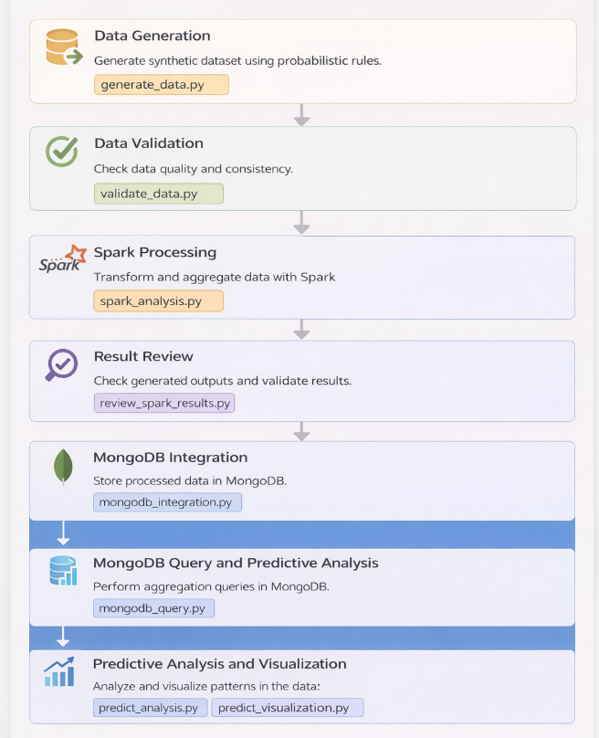
As illustrated in above figure, generate_data.py was generated to simulate forklift activity. This original raw data was stored in local driver before being loaded into MongoDB. The data includes timestamp, forklift_id, zone, shift, and status. Then, a validation step was done to check if the data is correct.
After that, using script, spark_analysis.py, to transform and aggregate data to get useful results, such as downtime patterns.
Next, the processed data was stored in MongoDB, by executing mongodb_integration.py. MongoDB was used as the main storage for processed data and integrated datasets.
Then, MongoDB queries were used to analyze the data again, such as aggregation and filtering. In mongodb_query.py.
Finally, predictive analysis and visualization were applied to understand the data patterns, using predict_analysis.py and predict_visualization.py.
Overall, the project follows a full pipeline from data generation to analysis and storage.

Spark transformations and queries performed

MongoDB integration and query performance tuning

References
Format the references using the Bibliography style. Delete this text. Update the bibliography below.
Centre for Occupational Safety. (n.d.). Puutavaran kuljetus jäällä. https://ttk.fi/tyoturvallisuus_ja_tyosuojelu/toimialakohtaista_tietoa/maatalousalat_ja_metsaala/turvallinen_tyoskentely_metsatoissa/puutavaran_kuljetus_jaalla.6730.news
Eduix. (n.d.). Wihi logo [image]. Eduix. https://eduix.fi/tuotteet-ja-palvelut/wihi/

Appendix x. Appendix Heading
This thesis appendix template has ready-made text for the title and the appendix number and automatic page numbering in the header. Fix the numbering and title of the attachment. In the header, replace only x with the correct number of the attachment. Do not change the header's automatic page numbering.
In your thesis, update the list of appendices on the table of contents page.
Remove these instructions from your appendices.

